## 

CEREBRAL PALSY UNITED

FOOTBALL CLUB

*NEWSLETTER*

*“Be the Best you can Be”*

Issue 9 – Dec 2015

**UP & COMING**

**CHRISTMAS EVENTS**

[](http://footballandmusic.co.uk/wp-content/uploads/2012/12/football_santas1.jpg)

**CoE:**

DATE: Saturday 12th December

VENUE: **RACK & DOLLAR – 27-35 Berry St Liverpool L1 9DF**

Time: Tables booked for 2pm.

There is a Christmas menu - £20 for 2 course inc drink.

There is a separate room with pool tables which we will be able hire on the day.

If you are travelling by train/public transport we will meet at the steps outside Lime Street Train Station at 1pm and walk up together. If not we will see you there! **Please let Ruth know your plans.**

**FOUNDATION:**

DATE: Sunday 13th December

VENUE: **LA Bowl Warrington WA2 8RF**

TIME: Please arrive no later than 12.45 for 1pm start. We will be finished just after 3pm.

The cost is £11.50 per head. Parents can you please pay half of this and we will pay the other half (cash on the day is fine).

This includes 2 games and some dinner, plus there is a DJ on too ☺

**ADULTS/FOUNDATION**

**& DEVELOPMENT - FIXTURES**

All age groups have now attended their first fixtures of the season and have all done very well.

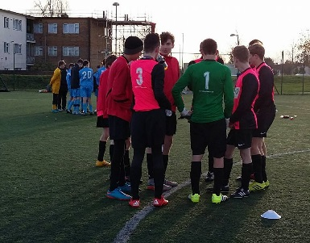

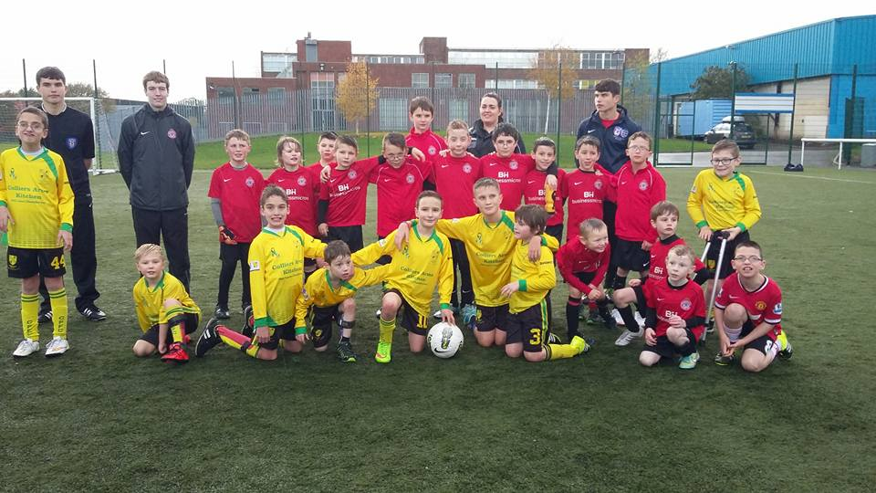

We are looking to arrange another fixture for the Foundation Group in February.

The next CoE and Adults fixture will take place over the weekend of 23rd & 24th Jan 2016. CP United will be hosting this at Partington (weather permitting).

**We will need volunteers to help on these days with the making of food, directing car parking, helping to put up posters, directing spectators/players. If** **anyone who wants to help out** please speak to Ruth and Michelle for details on this

**DATES FOR COMING BACK**

*Thank you to everyone for your efforts and commitment this past year.*

**All back on Sat 9th Jan:**

**Adults** 9 – 11 am

**CoE** 10 am – Yoga

11 – 1 pm Session

1.15 – 2 pm Recovery in Pool

**Foundation** 1-2pm

(bring trainers for indoor as well as boots in case we can use sports hall)

**OTHER NEWS**

 **CEREBRAL PALSY UNITED FOOTBALL CLUB – NEWSLETTER**

**£4,700 RAISED FROM OUR SPONSORED CHALLENGE**

**AMAZING!!!!!**

*THANK YOU THANK YOU*

*TO ALL INVOLVED & TO THOSE WHO DONATED - PLEASE PASS ON THE CLUBS SINCERE THANKS TO YOUR FAMILY & FRIENDS WHO HELPED US REACH THIS WONDERFUL TARGET FOR OUR CoE.*

*\*\*\*\*\*\*\*\*\*\*\*\*\*\*\*\*\*\**

We would also like to thank Ben Halsall’s Grandad for his continued support with the Boot Café in particular the water boiler which will help us tremendously when we are hosting tournaments/

fixtures at the club.

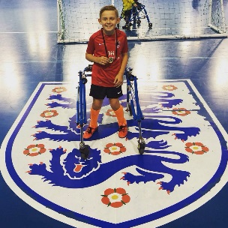Well done to Lee Reid from the Foundation group who took part in a National Frame Football event at St George's Park. He scored lots of goals and represented CP United brilliantly

**MONTHLY DONATIONS**

**& REGISTRATION**

WE WOULD LIKE TO REMIND EVERYONE to pay the registration fee of £15 & to set up your monthly donation of £10 via LOCAL GIVING (DON’T FORGET TO TICK THE GIFT AID!!!!).

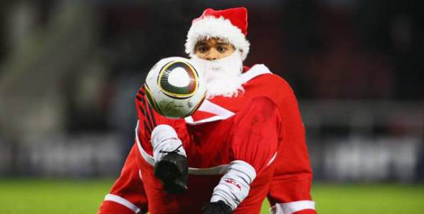Don’t worry if you don’t use the internet that’s fine just let us know and you can pay cash to us & we will collect it at the start of each month. **FOR THOSE WHO HAVEN’T YET PAID THEIR REG FEE IT WOULD BE APPRECIATED IF THIS COULD BE PAID ASAP. MANY THANKS.**

**THE CLUB WOULD LIKE TO THANK YOU FOR YOUR CONTINUED SUPPORT**



**We would like to take the opportunity to wish you all a very Merry Christmas & a Happy New Year.**

**Have a great time with your families, make some great memories, stay safe.**

***2016 will see us continue to grow & don't forget to try to get some training in over the break ☺***

[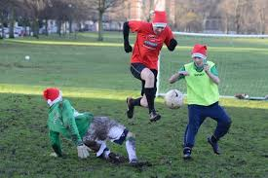](http://www.google.co.uk/url?sa=i&rct=j&q=&esrc=s&frm=1&source=images&cd=&cad=rja&uact=8&ved=0CAcQjRw&url=http://www.dailyrecord.co.uk/news/scottish-news/street-football-charity-host-kickabout-1505508&ei=souBVM_9BIf1UvnygPgO&bvm=bv.80642063,d.d24&psig=AFQjCNG6ZnIrsK_a23vtOH375uv07798QQ&ust=1417862417622116)[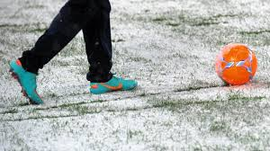](http://www.google.co.uk/url?sa=i&rct=j&q=&esrc=s&frm=1&source=images&cd=&cad=rja&uact=8&ved=0CAcQjRw&url=http://www.bbc.co.uk/sport/0/football/20836207&ei=0oeBVNHBKYmwUb7mgegP&bvm=bv.80642063,d.d24&psig=AFQjCNEFLIvhxE4_olJ9FMWTWC3MTJmtsQ&ust=1417861314345357)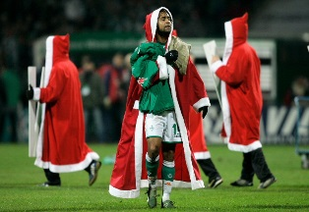[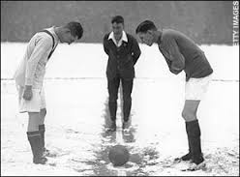](http://www.google.co.uk/url?sa=i&rct=j&q=&esrc=s&frm=1&source=images&cd=&cad=rja&uact=8&ved=0CAcQjRw&url=http://www.telegraph.co.uk/sport/columnists/jimwhite/2427498/Sober-new-face-of-festive-football.html&ei=EoiBVN-BBsn_Us3DgugP&bvm=bv.80642063,d.d24&psig=AFQjCNEFLIvhxE4_olJ9FMWTWC3MTJmtsQ&ust=1417861314345357)