## 

CEREBRAL PALSY UNITED

FOOTBALL CLUB

*NEWSLETTER*

*“Be the Best you can Be”*

Issue 10 – Jan 2016

**Happy new year & welcome back. another exciting year ahead!**

**CHRISTMAS PARTIES**

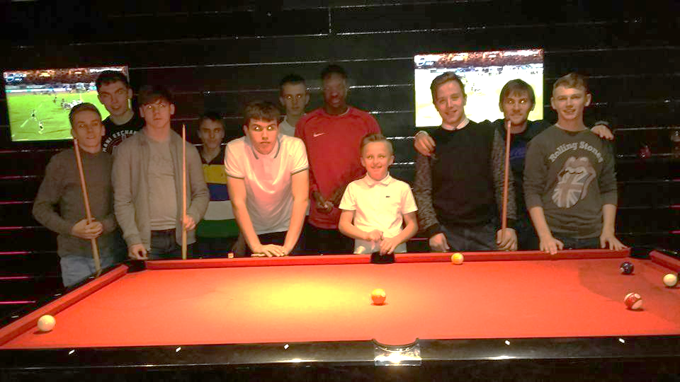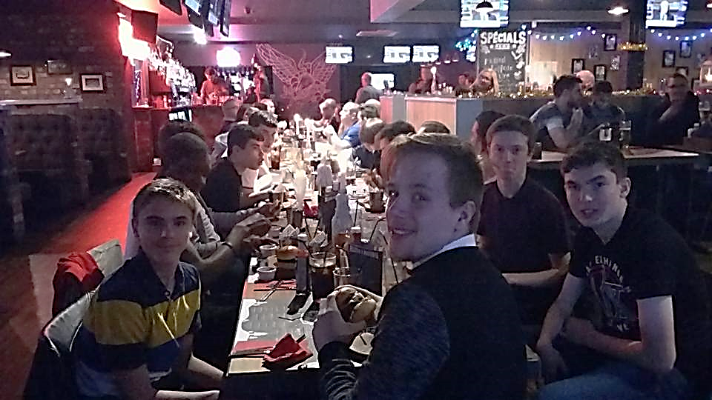Thanks to all who came to our Christmas social events. The meal and pool playing at Rack and Dollar was great and to have more than 40 people sat down enjoying a meal together was great!

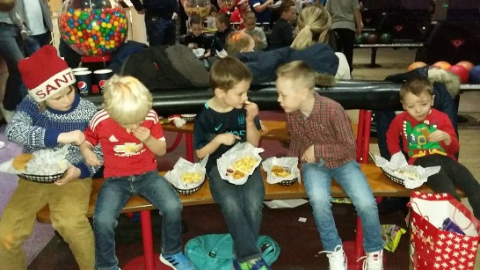Our day at LA bowl in Warrington for the Foundation groups was also well attended and LOTS of fun.

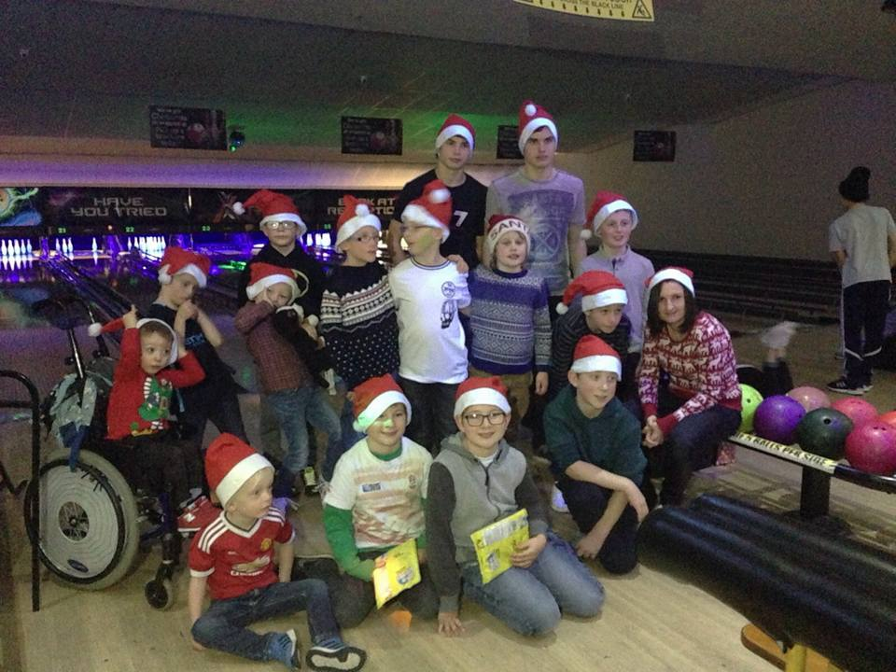

**We hope you all had a fantastic Christmas and a nice rest!**

**FOUNDATION**

A big well done to George from one of our Foundation group who "went viral" on Twitter over the Christmas break!!! We talk to our players a lot about "Be the Best you can Be" and "Striving For Excellence" and this little fella gets it!! He was out on New Year’s day doing his Christmas homework, which meant getting out there doing extra training. His Dad filmed it and uploaded a video on to Twitter. The video has over 2000 likes, has had over 1000 retweets and over 1000 replies!!!!! George even got a reply from one of his favourite Everton players Gerard Deulofeu who told him to "never give up on his dream and to stay strong"  Lots of people have been inspired by seeing George enjoying his football and his fantastic attitude to want to improve....so well done George in raising awareness of CP and CPUFC.

We are working on getting inside in the sports hall for most of Jan and Feb for the Foundation group but will let you know each week what surface we will have access too.

We are also looking at arranging another fixture for the foundation groups to play in Feb and March so watch this space :)

**ADULTS**

A massive thank you to Will Delaney one of our adult players who is not only a talented footballer but also a very talented singer.

He has decided he wants use this talent (which he is extremely shy about in the past) to raise some money for the club and has made a CD with a few songs on.  If anyone would like to buy one please see Ruth or Will. CDs are £5 and he has sold quite a few already to his family and friends and given all the money to the club.

Well done Will and Thank you!!!

**CENTRE OF EXCELLENCE**

Well done to all the COE lads who attended the FA Emerging Talent Program selection camp in Dec. All represented the North West and CPUFC very well both on and off the pitch.

**HOME FIXTURES**

**CoE**- **Saturday 23rd Jan at Partington**

We are again hosting the Centre of Excellence fixtures on Saturday 23rd Jan at Partington.

After the success of last year’s fixtures we are again looking for people to help out with the following on the day:

**VOLUNTEERS NEEDED WITH:**

* Cark park safety before/after the games. (See Brian)
* Catering (see Ruth) – ANY CONTRIBUTIONS APPRECIATED!!!
* Pitch and venue set up and clear up (see Michelle)

**Adults** - **Sunday 24th Jan at Partington**

This fixture program is not quite as big and some of our CoE staff will be on hand to help out, however anyone who would like to come and support the lads and help out with anything on the day is more than welcome.

**FOUNDATION GROUP - Please note** we will still be holding our Foundation groups sessions on Saturday 23rd Jan (times may change slightly but we will let you know over the next week) Please feel free to come along earlier to watch our older Centre of Excellence boys in action or stay later to see the remainder of the fixtures.

**NEW SESSIONS - LIVERPOOL**

 **CEREBRAL PALSY UNITED FOOTBALL CLUB – NEWSLETTER**

We had some taster sessions booked in before Christmas but unfortunately we only managed to get one in due to the severe weather and flooding we experienced in the NW.

The session we did do was great and we have players ready and waiting to get going when we start up again.

The dates for the sessions at Walton are to be confirmed by LCFA in the next week so we will update the website and social media to inform people of this. Sessions will be held at Walton Sports Centre, home of LCFA on Monday nights 6-7pm.

**CPUFC – TEAM BUILDING DAY**

**TUESDAY 16th FEBRUARY 2016**

Petty Pool Trust in Cheshire have offered us the use of their outdoors centre in the February half term (Tuesday 16th).

We are hoping to take up to 30 players along to experience their facilities and take part in confidence building, problem solving and team work challenges throughout the day.

Players from **ALL** age groups are welcome and activities will be tailor made to suit individual and group needs. The cost is £15 per head, with the club also contributing £5 towards everyone's fee.

For more information on the centre (which is run by our former adults coach Lee Burke) please visit <http://www.pettypool.org.uk/outdoor-centre/>

As you are all aware part of our philosophy at the club is to help and support our players to not only develop as footballers but as people and providing opportunities and experiences like this is we feel is key.

If you would like to come along please put your name down with Ruth asap. We will need to know final numbers by Saturday 30th Jan 2016.

(Parents/carers are welcome to come along for the day but you are also welcome to drop off and pick up at the end of the day...times to be confirmed in the coming weeks).

**DONATIONS**

**& REGISTRATION**

**ALL YOUR DONATIONS ARE GRATEFULLY APPRECIATED.**

**IF YOU WOULD LIKE TO PAY VIA LOCAL GIVING :**

[**https://localgiving.com/charity/cerebralpalsyunitedfc**](https://localgiving.com/charity/cerebralpalsyunitedfc)

**THE CLUB WOULD LIKE TO THANK YOU FOR YOUR CONTINUED SUPPORT**

