+

CEREBRAL PALSY UNITED

FOOTBALL CLUB

*NEWSLETTER*

*“Be the Best you can Be”*

## 

Issue 21 – Feb 17

**FOUNDATION/TOTS/DEVELOPMENT**

**FIXTURES**

Warrington Inclusion League starts up again on Monday 27th Feb at Orford Jubilee Centre, Jubilee Way, Warrington, WA2 8HE.

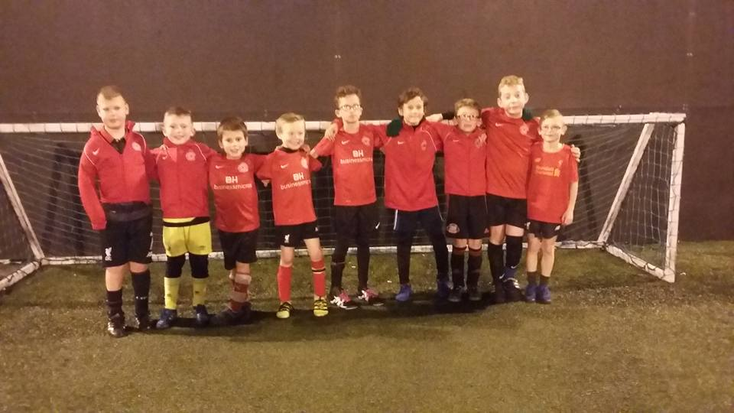

Please let Michelle know by Saturday 18th if you would like to come and play.  We will meet in reception at 6.40pm, KO will be 7pm and finish at 8.30pm.

(For 7-13 year old club and RTC players).

Our trip to the Fleetwood v Rochdale game has unfortunately been cancelled. The arrangements made were for CP United players to be mascots for the game and play on the pitch at half time. Unfortunately the experience of playing on the pitch at HT is now not available so we have decided to stick to training instead. Training at Partington on 11th Feb is 1-2pm as usual. Sorry for any inconvenience or any disappointed this may have caused, but unfortunately it is out of our hands. Thanks to Tommy Laughran (Ollie's dad) for trying to sort this out initially with Fleetwood.

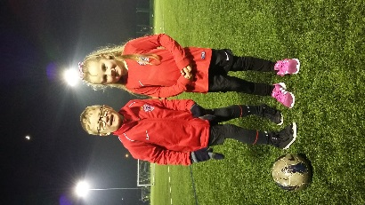**New sessions in Cheshire:** In March we are due to start localised provision in Cheshire in partnership with Cheshire County FA. This first session will be on Thursday 16th March 5-6pm. If you can help us advertise these sessions that would be great. New players are welcome as well as current players who are local to Cheshire and would like to access some midweek training. Sessions will be held at Cheshire FA Football Centre, Moss Farm, Northwich, Cheshire CW8 4BG. Please let Michelle know before 16th March if you will be coming along. (please see fb/twitter pages and website for more details) .

**ADULT PHASE**

Well done to both our adult squads who won all their games in the recent National League Fixtures. Another valuable day of development and game time as they prepare for end of season competitions.

**Barcelona Tournament** - This coming June (8th – 11th) we will be taking one adult team to Barcelona to play in the International Cup. This will be a fantastic experience for our players and we will keep you all updated about this exciting opportunity in the coming months.

[](http://www.google.co.uk/url?sa=i&rct=j&q=&esrc=s&source=images&cd=&cad=rja&uact=8&ved=0ahUKEwif5smA-fPRAhWpBcAKHTACAEwQjRwIBw&url=http://www.123rf.com/stock-photo/spinning.html&psig=AFQjCNH9nDPS_DFEK7cX6CFheV7W6RH2NA&ust=1486211885257094)**Fundraising for Barcelona -** In the coming months our adult players will be raising money to help fund their trip by doing a sponsored spin, we will provide details on this in next month’s newsletter.

**Fixtures** – Sean will give details out about this once confirmed with CP Sport.

**REGIONAL TALENT CENTRE**

**FIXTURES**

**Nottingham** - Some good lessons learnt at our recent Futsal fixtures for both u14 and u17 squads. Now we need to build on these lessons, keep training hard and keep developing.  Apologies again regarding the viewing situation to all parents and families who came along to support.

**Coventry -** PLEASE travel on the coach if possible. Coach will leave Partington at 7.30am and arrive back approx 6pm. We need to know numbers for the coach by no later than Saturday 18th Feb. Cost £5 pp.

The venue will be Moat House Neighbourhood & Leisure Centre, Winston Avenue, CV2 1DX. At this fixture we will play 7v7 football as normal.

**Friendly Fixtures** - we will have fixtures v non CP teams in the coming weeks for both our u17 and u14 squads, we will let you know about this via text. (First one 11th Feb v AFC Oldham for u17s at Partington).

**Outstanding Season fee's** - any owed please pay by end of March 2017 (total £50) thanks.

**Well done to Sam Dewhirst** from our u17 squad who has been given a place in this seasons FA Emerging Talent Program. He will attend 4 camps at Hereford throughout the season and is the youngest player in the country to have been selected.

**FUTURES PROGRAMME**

Due to the growing number of people involved in our Futures Program we will be having a workshop one Saturday after training (2.15-3.30) in the coming weeks to support our young coaches and their development. We will let you know the date of this in the near future.

**Congratulations to Dylan Coady** from our adults squad who has been offered a job in the USA with Challanger sports over the summer. Dylan will coach football over in the states and is the third person from our futures program to be offered this fantastic opportunity. He is currently supporting our u14 squad and foundation groups whilst also working towards his FA level 2 coaching badge. Well done Dylan.

**FA CHARTER STANDARD DEVELOPMENT CLUB STATUS**

This is something we have been working towards for the past few months and recently had confirmed by Manchester FA. This means the FA have recognised we are operating at a high standard and have a real focus on the development of players and the club as a whole. Well done and thanks to all who helped with this process.

**CLUB SHOP**

Some players have now started to access the club shop and add extra kit to what they already have. If you would like to use this facility please follow this link...........

<http://www.clubwebshop.com/a-z/clubs/cerebralpalsyunitedfc/>

You will need to register as a member before you can buy anything *please note you may have to attach the club badge to garments if it is not already assigned to the item. (please use the embroidered badge option).

**CHARITY STATUS UPDATE**

We are 3/4 of the way through this process now and over the coming weeks/months we will be submitting our application to the charity commission. Thanks to everyone who is working hard on this (especially Pete) and to the 5 wonderful people who have agreed to be Trustee's. We will keep you updated on this process.

**SAINSBURYS ACTIVE VOUCHERS**

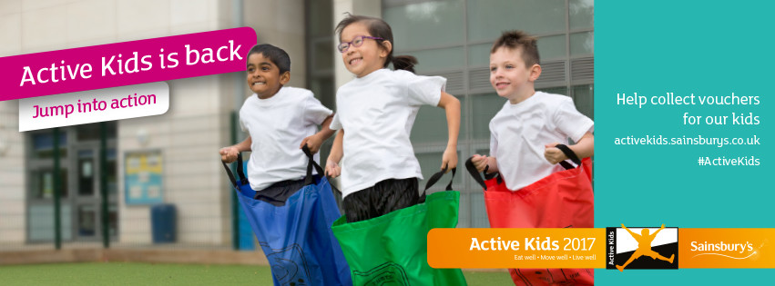

We are collecting Sainsburys Active Kids Vouchers again ☺ There is a collection box in the Community Room by the Boot Café or if you can pass them through to either Ruth/Michelle/Brian. THANK YOU.

**CP UNITED PHOTO BOOK**

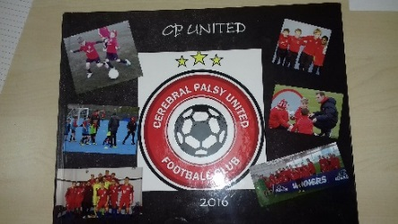This book has been put together by Tommy Loughran (Ollie's dad) it contains lots of pictures from last season and is a lovely keepsake. There are photos in it from across all the age groups and we have had a few people ask can they get one.

The manufacturer of the book have said if we get 20 orders they will cut the price of the book to £22.   
Another of our parents suggested we make it £25 and the club will make £3 on them.

(You can still get it for £22 if you'd like, no worries)  
Please see Ruth in the community room if you would like to get a copy. https://static.xx.fbcdn.net/images/emoji.php/v7/faf/1/16/26bd.png

**FUNDRAISING**

Joe Curley (a relation of one of our little superstars Louis Henry) is running the Halstead marathon on May 7th and wants to raise money for our football club.

<https://www.justgiving.com/crowdfunding/joe-curley>kind gesture! https://static.xx.fbcdn.net/images/emoji.php/v7/fab/1/16/1f3c3_200d_2642.png🏃

<https://www.justgiving.com/crowdfunding/joe-curley>

If anyone can sponsor him it would be very much appreciated. Thank you Joe for your efforts...good luck with all the training.

**SPONSORSHIP & DONATIONS**

A big thanks to Joe from everyone involved at the club for his hard work and kind gesture! https://static.xx.fbcdn.net/images/emoji.php/v7/fab/1/16/1f3c3_200d_2642.png🏃

[https://www.justgiving.com/crowdfunding/joe-curley](https://l.facebook.com/l.php?u=https%3A%2F%2Fwww.justgiving.com%2Fcrowdfunding%2Fjoe-curley&h=ATOJRtc8HccwhyXS09loSpFbZPwbOMFsyKTGZoMZXkV9fS8xVzrf3X_IkgpLywqTAoz1Kt4Ca4hKPZlYNbkjAiYyEWfuLkE7mT6-CvYoaZROBme958jIPuS1D54zWGJDEko&enc=AZPg8IunZCjZCE-1_9srHuoC0W9ML46mZPcZpjlDBaciQow9zaRv2p011RhH1YEmId-Mov0VlMfNngrQNrc4E6dgNOwxCz0W1aKtkwluMAF20JQAKbwaSLOiWnInM8I7jJ_bLt3l0HwsGb6AC5hPGCtwAaKxy-W30kO0gyQxGHRJKmCHF5SFULLfff5Q3wkwvko7QKin2SwgRAeOTu22LBVJ&s=1)

Thank you to everyone who is now set up on a monthly donation payment scheme is really does help to keep things ticking over.

You can do this via the online set up (details below) or if you need to pay cash that is fine too. Any help you can give would make a big difference.

**SORT CODE: 30-84-63**

**ACCOUNT NO: 57958560**

**ACCOUNT NAME: CP UNITED FOOTBALL CLUB**